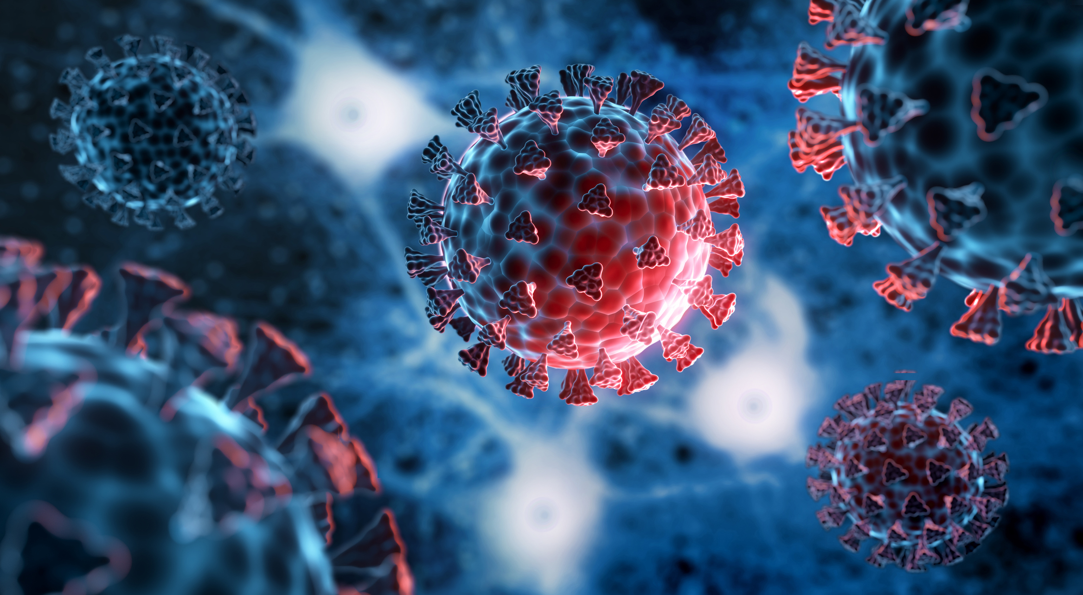

July 2022

What Have We Learned About Inflammation and Thrombosis Since the COVID-19 outbreak?

Part 2: The Link between COVID-19 Infection, Thrombosis and Long COVID

Featuring:
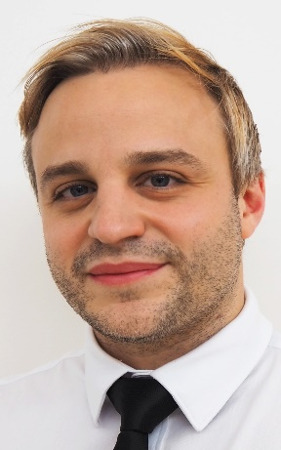
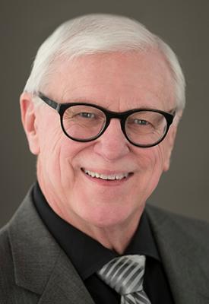
Moderator
Mr. George Fritsma, MS, MLS
Laboratory Scientist

Guest
Brandon M. Henry, MD
Physician Scientist

Transcript of the Conversation – Part 2:
Mr. Fritsma: Welcome to Coag Conversations, an educational series sponsored by BioMedica Diagnostics of Windsor, Nova Scotia, Canada. I'm George Fritsma, faculty for the University of Alabama at Birmingham School of Medicine, Division of Laboratory Medicine, and proprietor of the Fritsma Factor, your Interactive Hemostasis Resource where we exchange current coagulation information.
We welcome you to our three-part series: What have we learned about Inflammation and Thrombosis since the COVID-19 outbreak?
Our guest is Doctor Brandon Henry, a Physician Scientist and Investigative Pathologist affiliated with the Cincinnati Children's Hospital Medical Center, in Cincinnati, OH, USA.
To date, he has published over 300 articles, including 150 plus articles on SARS-CoV-2 infection, which have already been cited over 10,000 times. Doctor Henry is America's most published COVID-19 scientist and according to a recent analysis of Scopus, he is ranked among the most published and most impactful researchers in the world of COVID-19. Doctor Henry is the leader of multiple international studies investigating COVID-19. His research focuses on the intersection of virology, immunology, and hemostasis. Over the last two years he worked to unravel COVID-19 pathophysiology, elucidating the mechanisms driving COVID-19 associated coagulopathy, immunopathology, and multi-organ injury.
Doctor Henry serves as an international advisor on COVID-19 response to multiple regional and national public health agencies and is the Chair of the International Federation of Clinical Chemistry and Laboratory Medicine SARS-CoV-2 Variants Working Group. Doctor Henry, do you have a few comments?
Dr. Henry: Hi George, I'm excited to be here today. The significant progress that we have made in studying COVID-19 associated coagulopathy over the last couple years will pay many dividends in the years to come for many other thrombotic diseases. Indeed, it has become very clear to physicians and scientists that thrombosis and inflammation are inherently linked and that we can't study one in isolation without consideration of the other. So, the major scientific advances in understanding thromboinflammation seen in COVID-19, I believe, will cause a paradigm shift in our research approach to many other conditions such as myocardial infarction and stroke. This will not only advance our scientific knowledge, but really enable new therapeutic approaches, even novel diagnostics. So, with that, I'm excited. Let's dive into our talk.
Mr. Fritsma: We continue with Part Two of our discussion. What have we learned about inflammation and thrombosis since the COVID-19 outbreak? And our Part 2 discussion is:
The Link between COVID-19 Infection, Thrombosis and Long COVID
Mr. Fritsma: Doctor Henry, to start with, the symptoms of Long COVID are very broad, encompassing symptoms from head to toe, how do we classify these and are they related?
Dr. Henry: Long COVID, like COVID, is an extremely heterogeneous disease, or better yet, group of still poorly defined diseases. The vast number of symptoms and different disease presentations makes classifying it very difficult, as is understanding if there are relationships between these different symptoms and different disease courses. Let's step back. Let's look at a little bit of data on symptomatology and what we see in Long COVID and then we can think about a bit of classification.
So this is an excellent meta-analysis that was done that looked at the effects of Long COVID. It looked at a very large population, so it looked at a number of different studies and it put together a picture of the symptomatology that we see in Long COVID. And as you can see, the symptoms are very broad. Some of the most common are the fatigue, the headache and of course the brain fog that we've all heard about, going across nearly every system of the body. It really is a head-to-toe presentation, so this makes trying to understand what was driving this and how to classify it very difficult. We have everything from neurologic symptoms, psychiatric symptoms like paranoia and PTSD, to things like pulmonary fibrosis, chest pain, cough. So, it's a very broad picture that is Long COVID. We also can see here they also listed some laboratory values. They found D-dimer. We're looking at post COVID. 20% of people had elevated D-dimer, BNP [brain natriuretic peptide], CRP and of course the inflammatory biomarkers like serum ferritin, CRP, IL-6, procalcitonin, lactic acid, calprotectin, erythrocyte sedimentation rate [ESR].
So, indeed, it is a very heterogeneous picture and it makes one trying to understand what's driving this. How we classify this is very difficult. Is it one disease or is it several diseases? Do people have different progressions? Is it one thing? And this is a study that recently came out that I think gave me a little bit of pause. This study was done looking at a number of veterans using the US Department of Veteran Affairs database and it included over 180,000 participants who had a COVID-19 infection. They were looking particularly at the risk of developing diabetes. They found that those with COVID-19 were 40% more likely to develop diabetes up to a year later than were veterans in the control group. It just gives you an idea that we could be seeing long effects that affect many organs, many tissues and that we're just beginning to understand so, when we think about classification, the British put out their own very early-on guidelines, so they defined acute COVID which is within the first 4 weeks and then they define Long COVID as new or ongoing symptoms 4 weeks or more after the start of acute COVID, which that they divided into two groups, those for four to 12 weeks and 12 or more weeks.
I don't think that classification really works too well but let me give my idea of how I classify this, at least in terms of what I'm doing about the pathophysiology. I think that we can really break it down into three groups of conditions: those are the prolonged symptomatic COVID, so these are people who have the prolonged symptoms, the cough, fever. Now, that doesn't really go away. And then we have the post-acute sequelae of SARS-CoV-2 infection. With this I'm thinking about things like myocardial infarction, stroke, diabetes, these new diseases that may be due to remnants of the viral infection. Damage to tissue, endothelial damage, heart damage that already occurred, vascular damage that already occurred and we're starting to see that in follow up to those.
And finally, then we have the Long COVID the ones that are people with brain fog, for example, that I'm thinking about. That are brain fog for several months that doesn't really fit into the one of the other two categories, so I think, at least for me, this is how I approach Long COVID. I'm thinking about it from one of these three perspectives. Hopefully in time, we'll have better classifications of Long COVID. But I think we're still trying to unravel that picture. Understanding what the different diseases are and how we can classify them is really going to be key in order to start to develop a clinical plan to really deal with these.
Mr. Fritsma: Thank you. It is really interesting to me—I met a young man. He was probably 31 or 32 who had developed diabetes after COVID, and that had surprised me at the time. I hadn't heard of that, so your data is interesting related to diabetes. Do the various Long COVID symptoms share one common mechanism and is it an extension of the COVID-19 pathophysiology?
Dr. Henry: No, this is a very interesting question, and we're still just sort of scratching the surface at understanding what drives Long COVID. As I mentioned earlier, as we all know, Long COVID is very heterogeneous collection of symptoms and probably in my opinion represents a number of distinct pathophysiologic processes and different diseases. Let's jump to a couple of short slides and I'll show you what I think we know so far.
So, I showed you this classification earlier and I liked it. As I mentioned, because it connects to the path of physiology, at least how I break it down. And here we can see some of the proposed mechanisms of Long COVID. So, the first one we can think about, the prolonged, symptomatic COVID-19. People may have persistent or chronic infection. So, they may be long haulers like those with a sub-acute type infection. They may have some type of persistent inflammation. And that sort of fits into the picture. Those are some of the potential paths of these alleged processes. They may drive this prolonged symptomatic COVID-19. You might think about people here in years past. The post-acute sequela SARS-CoV-2 infection, where it gets a little more complicated. I think certainly we're thinking about direct or indirect viral mediated tissue injury.
Ongoing inflammation due to post infection, immune system dysregulation, vascular injury leading to a persistent prothrombotic state or dysregulated renin-angiotensin system. Then we think about the true Long COVID. We're certainly thinking about an autoimmune-type condition or again dysregulated angiotensin-aldosterone system, maybe due to anti-idiotype antibodies. But this is not a comprehensive list. These things likely overlap, and we're just starting to really try to understand what this is and it's going to be a great scientific challenge.
A few really interesting things that I think are really worth pointing out, but this was a really great study that was done and published in Cardiovascular Diabetology, and it looked at persistent clotting protein pathology in Long COVID. They found micro clots. Now you're probably going to start hearing a lot about these particular micro clots. They found it to be associated with increased levels of antiplasmin. What they thought, was that we hear a lot about recurring fatigue or muscle weakness or sleep difficulties. They suspected that blood clots might be blocking micro capillaries and thereby inhibiting oxygen exchange. They investigated if lingering symptoms of Long COVID might manifest due to the presence of persistent circulating plasma micro clots that are resistant to fibrinolysis. They found that many patients with Long COVID still had these large amyloid deposits with these micro clots. They found them to be resistant to fibrinolysis and that if they did a couple cycles of trypsinization they were able to solubilize the clots.
They also found that they were associated with various inflammatory molecules that were subsequently trapped in the pellet within the clot. They also found that this was associated with a substantial increase in alpha 2 antiplasmin, various fibrinogen changes as well as serum amyloid A. So, those were all trapped within these pellet-like clots. And they concluded that clotting pathologies in both acute COVID-19 infection and Long COVID might benefit from continued anti-clotting therapy to support fibrinolysis. Not only just in the acute phase, but also going into the long phase. This was a great review where they sort of talked about whether or not we should continue our anticoagulation that we started on, hopefully early in the disease course in patients with severe COVID-19.
And they also looked at this and proposed that many of these symptoms that we're seeing with Long COVID are likely a continuation of the prothrombotic state. They suspected that a number of different factors may be coming into play. But of course, endothelial damage, persistent dysfunction, the chronic hypoxia that's probably driven by these micro clot type things or the prothrombotic state. As well as persistent immune dysfunction, persistence of SARS-CoV-2 and a few other mechanisms by which the virus may be able to continue to wreak havoc, even afterwards. But again, it really comes down to bit of a prothrombotic state that's really perpetuating at least a large majority of the symptoms that we see.
Another really interesting potential mechanism, George, I think is worth highlighting is anti-idiotype antibodies and how this may actually impact the microvasculature. The renin-angiotensin-aldosterone system regulates blood pressure as it regulates electrolytes. But it's really important for endothelial function as well as maintaining proper hemostasis.
ACE 2 is essential for maintaining endothelium, platelet function as well as the normal cardiovascular physiology. One suspected thing that we started to see some evidence of is that when we get infection, we produce antibodies. I think we all know now that Sars-CoV2 enters by spike protein which binds to ACE 2. And what happens is we produce antibodies after infection. During the course of infection, we start to produce antibodies against the spike protein.
Well, another phenomenon that could happen is that we could make antibodies against the antibodies. So, we end up with these antibodies against the antibodies, but these antibodies are not only to be able to bind the antibody. But they're also able to bind ACE 2. And when they do that, they knock out ACE 2 so we lose this really valuable regulator at the endothelium that regulates the hemostasis, especially primary hemostasis.
And this also could be playing a major factor in contributing to what we see in the picture of Long COVID.
Mr. Fritsma: So from the discussion, it really looks like Long COVID—you would categorize it as a prothrombotic state, and you've given quite a bit of evidence for this. Is there any more evidence supporting pro thrombosis in Long COVID?
Dr. Henry: I think Long COVID no matter the classification, no matter the mechanism, is indeed associated with the pro-thrombotic state. The clinical evidence to support this is accumulating rapidly and frankly, it's quite scary. Indeed, it's not clear that even patients with—I'm sorry—I should say that it's now very clear that patients with asymptomatic or mild COVID are at increased risk of major cardiovascular events like myocardial infarction as well as other thrombotic events, like ischemic stroke after COVID-19. Let's look at a few more studies that really highlight the clinical data that we see.
Dr. Henry: So this was a great review that looked at some of the early data that we had to support abnormal coagulation with Long COVID and again they started to put together this picture pretty early on that we see increased risk of venous thromboemboli and arterial thromboemboli after discharge and if that post discharge anticoagulation reduced the risk by about 46%. This was an excellent study that's done by Giannis, et al, back in 2020.
A few other things that they started to point out in their review on this study by Pasini, which I think we'll talk about a little bit later. They found a persistence of altered D-dimer levels, raises the possibility of thromboembolic disease and overall, they started to see a number of studies that reported different clotting pathologies in Long COVID that suggested that we might want to pay attention to abnormal coagulation as a major factor in Long COVID.
And in the last couple months this has become much more apparent, much more clear. This was a really big study, done again using the database of the US Department of Veteran Affairs looking at 153,000 persons with COVID compared to nearly 10 million controls. What they found was that the risk of major cardiovascular events after COVID-19 were extremely high, so the risk of stroke, the risk of TIA [transient ischemic attack], cerebrovascular disorders, dysrhythmias like A-fib, sinus tachycardia. We can see on the right here the hazard ratios for all of these. Pericarditis, myocarditis, acute coronary disease, MI, ischemic cardiomyopathy, angina and the list goes on and on and on. Pulmonary embolism and DVT. Superficial vein thrombosis. They were all much higher in patients up to one year after COVID-19 and they broke it down even a little bit further, George.
What they looked at was they broke it down by non-hospitalized, hospitalized, in ICU. And not surprisingly, the risk of these bad cardiovascular events occurring in patients, were, in the ICU, the highest. But when we even look at non hospitalized people, we can see that they're at increased risk compared to historical controls of every single one of these conditions minus cardiac arrest and cardiogenic shock.
But when we think about thrombotic disorders, PE, DVT, superficial vein thrombosis. So, these are patients who are not hospitalized, so mild COVID-19 are at increased risk for these types of thrombotic events after COVID-19. When we look at things like coronary disease, MI, stroke, this is quite scary for patients who did not have a very serious case and really sort of points to us that there might really be a major problem going on with some type of abnormal coagulation post and acute COVID-19. And this was backed up by another study that came out of Sweden that really showed the same thing that there was increased risk of acute myocardial infarction and stroke after COVID-19. So, George, I think when you look at the summary of evidence that we've seen, it is quite clear that Long COVID is associated with prothrombotic state, but everybody after COVID-19 is that some increased risk of a major type of thrombotic event. We need to be monitoring for that.
Mr. Fritsma: OK, so in terms of Long COVID, does vaccination impact the risk of post COVID sequelae and Long COVID?
Dr. Henry: This is a really important question and one I've asked quite frequently. The overall evidence to date has been mixed, but I would say the majority of evidence really suggests that the risk of Long COVID is indeed reduced in vaccination by, say, about half. But when we consider the number of breakthrough infections that we've seen in the last several months, we're talking probably about 100 million Americans and more that were infected with Omicron. And when we consider that the incidence of Long COVID, the rate is between 10 to 20%, so that's maybe 5% of those that were infected. We're talking about millions of cases, potential cases of Long COVID, in the US alone. Now, we don't yet know how novel variants like Omicron’s sub lineages impact Long COVID. It will require time to tell. But to be clear, Long COVID is terrible and it's a devastating disease. So, I encourage everyone to do what they can to prevent Long COVID and that begins with getting your vaccine boosters and reducing your risk of infection by taking COVID-19 precautions as appropriate, so we can avoid further suffering.
Mr. Fritsma: Well, this is very important information, and it touches me personally. I'm one of the people who had a breakthrough infection after having the first Pfizer booster. What are the prospects for patients who are experiencing Long COVID at this point?
Dr. Henry: At this time we do not have any effective therapies for Long COVID, let me be direct here. Treating Long COVID is science’s next great challenge. Now different drugs have been commonly used clinically. I've seen steroids use commonly, given to patients with Long COVID after they've seen any significant indication that they work. Yet novel antiviral drugs like paxlovid, but these might be useful for some of the people that we talked about that may have that sort of chronic infection or the prolonged symptoms. However, this probably represents a limited number of the Long COVID cases.
Now there are clinical trials ongoing. There's the Stimulate ICT trial at the University College of London, which will compare the effectiveness of a few different drugs, testing anti-histamines, cimetidine [Tagamet] and loratadine [Claritin] to prevent mass cell activation. We're going to test rivaroxaban, which is a direct factor Xa inhibitor, and that's to target those micro clots that we had mentioned a little bit earlier. Again, they think that is could be a major factor by reducing oxygenation to large muscles during exercise and sort of causing that post-exertional malaise or fatigue describing patients post COVID. They're also testing out colchicine which is an anti-inflammatory drug. Overall, significant efforts are being made to understand the pathophysiology of Long COVID.
As we mentioned, the heterogeneity of the condition makes it quite challenging. But as we begin to describe the mechanisms driving this disease, or diseases, we'll hopefully be able to develop targeted and or broad therapeutic approaches to treat it effectively. That said there is no doubt that Long COVID is going to haunt us for quite a while. Possibly for many decades and we may have not seen the worst of it yet, as many post-viral infections do not develop, sometimes for many years, sometimes even decades later. It's imperative that we continue to prioritize and invest in research studying SARS-CoV-2 infection and Long COVID.
Mr. Fritsma: Well, thank you for that information. It's not the most encouraging information, but I hope we're on our way. This concludes today's conversation. Please join us next month as we continue our discussion about what have we learned about inflammation and thrombosis since the COVID-19 outbreak.
Doctor Henry, thank you for your expertise and thanks to our audience for your participation. Look forward to next month.
Questions or Comments: Webinars@BioMedicaDiagnostics.com

